DS LAB 2

Date: 5/08/24

Name: Utkarsh Yadav

Roll: 23053172

2.1 WAP to create a 1-D array of n elements and perform the following menu based operations using

function.

a. insert a given element at specific position.

b. delete an element from a specific position of the array.

c. linear search to search an element

d. traversal of the array

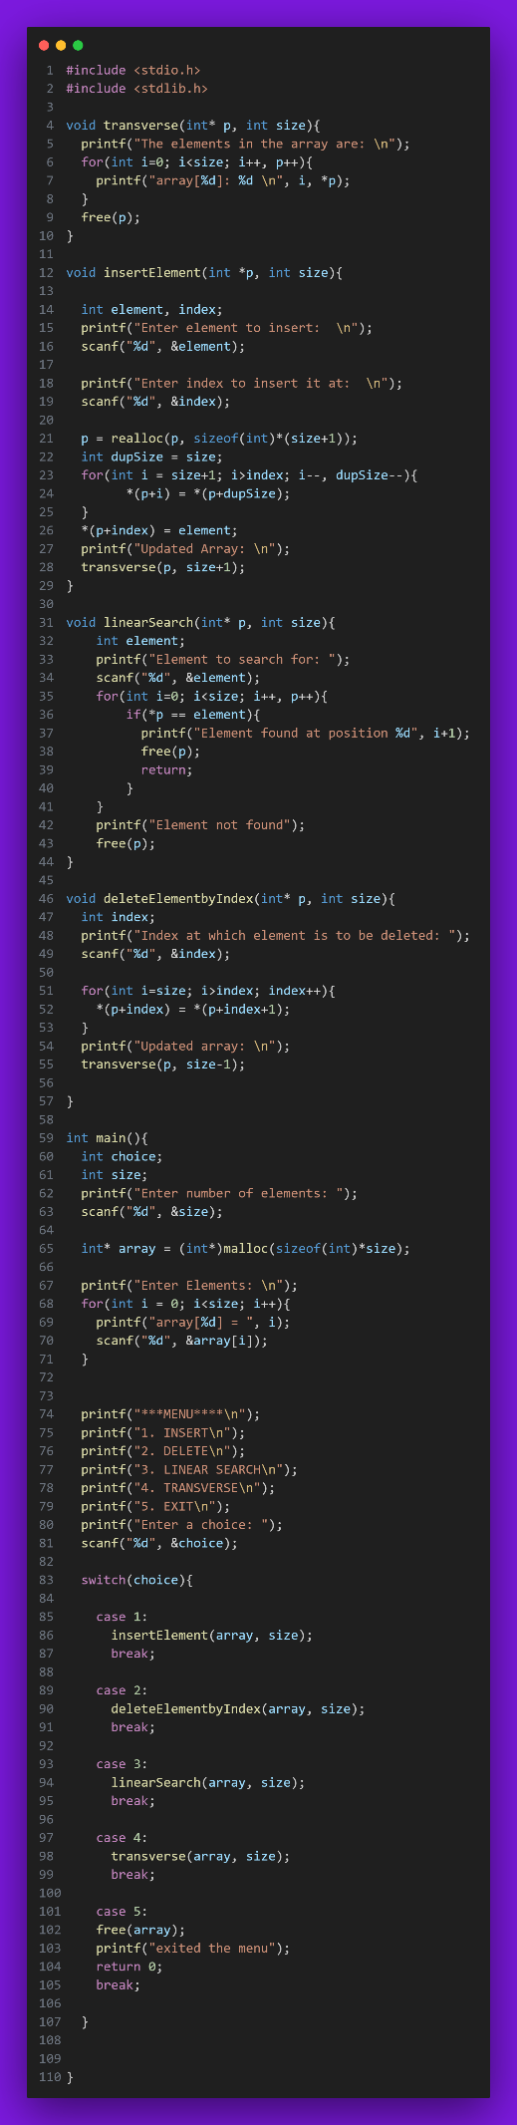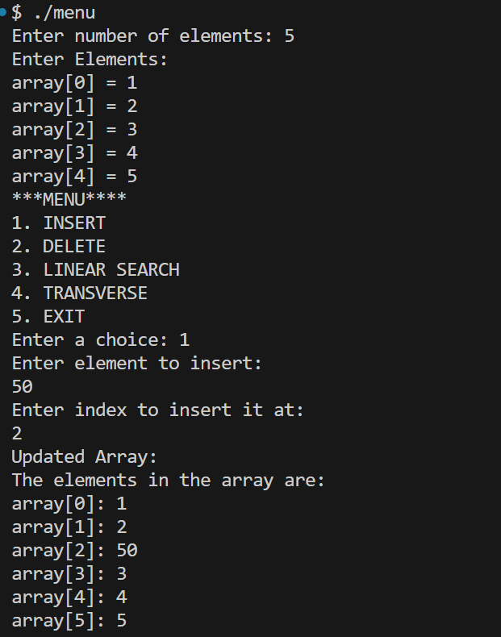

2.2 Write a program to perform the following operations on a given square matrix using functions:

i. Find the no.of nonzero elements

ii. Display upper triangular matrix

iii. Display the elements of just above and below the main diagonal

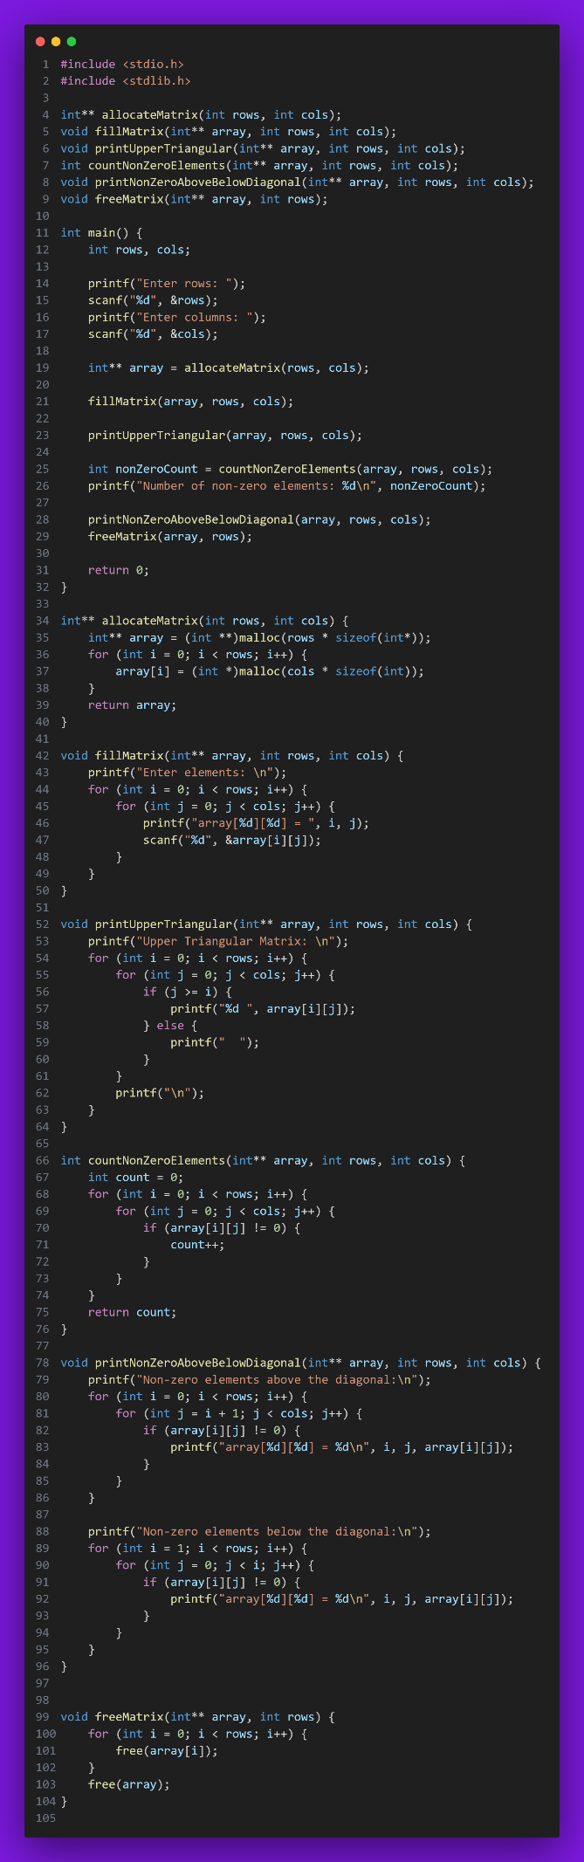

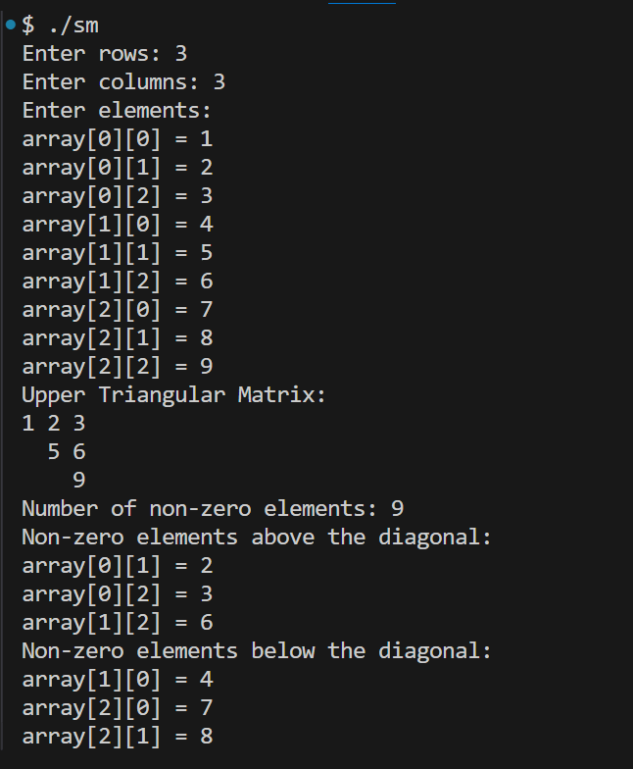

2.3 WAP to represent a given sparse matrix in 3-tuple format using 2-D array.

